**Capstone Coursera – Applied Data Science Capstone**

**Robert Sharkey**

**22/02/2020**

**Introduction**

Background:

New York City is the largest city in the United states and has a deep heritage, understanding and famous history in terms of their bakeries, bread shops and now the upcoming crepe and waffle industry

The tradition of bread started all the way back in 1678 when the Hudson Valley was discovered as a leading source of wheat to the West indies. In 1820 the famous soft pretzels which we know today became a popular street food.

In 1911 a New York observer article stated that preventing infant mortality that One-year Olds should have stale bread. We all like sweets and treats when we visit so this project is good for those people that are travelling or will be staying in New York City in the future.

***Methodologies***

**Data: Where we obtained the Data**

New York City data that contains list Boroughs, Neighborhoods along with their latitude and longitude.

* **Data source:**
* <https://cocl.us/new_york_dataset>
* **Description:**
* This data set contains the required information. And we will use this data set to explore various neighborhoods of New York city. Bread shops in each neighborhood of New York city.
* **Data source:**
* Foursquare API
* **Description:**
* By using this API, we will get all the venues in each neighborhood. We can filter these venues to get only bread shops which include Bakeries, Donut Shops, Creperie and Bagel Shops.
* **Geospace data**
* **Data source:**
* <https://data.cityofnewyork.us/City-Government/Borough-Boundaries/tqmj-j8zm>
* **Description:**
* By using this geo space data we will get the New York Borough boundaries that will help us visualize choropleth map

Questions we will ask?

* What is the best location for bread shops in New York City?
* Where in New York is there minimal bread shops in New York City?
* Which areas have potential investment for a bread shop?
* Is there a bread shop located to many hotels?
* Is there a decline in Bread Shops due to the Covid Pandemic?

**New York City Neighborhoods Map**

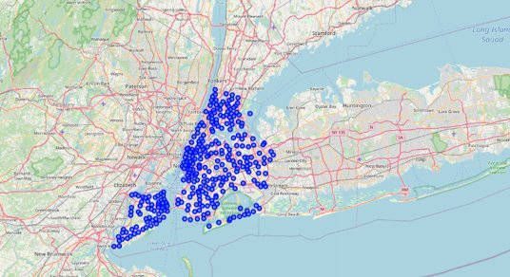

Bread Shops which include Donut Shops, Bakeries, Bagel Shops and Creperies

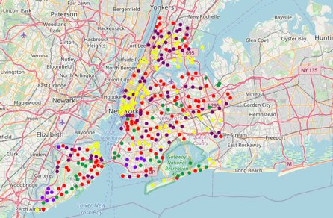

**Bread Shop Statistics**

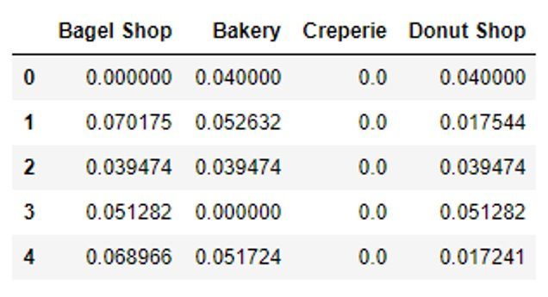

**Most Common Venues**

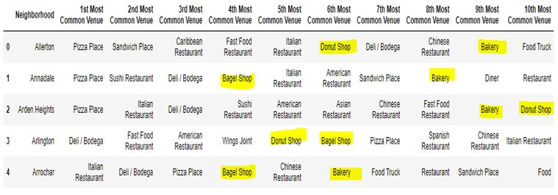

**Conclusions**

* Brooklyn is the most common neighborhood area for bread shops using the statistics and graphs.
* Manhattan is the neighborhood for the potential investment of a bread shop (Donut Shop, Bakery, Creperie and Bagel Shop)
* Creperies are the least common across New York which is also a potential good Investment.
* There is a decline in Bread Shops due to the Corona Virus Pandemic, please read: <https://www.forbes.com/sites/garystern/2021/02/03/declining-rents-trigger-sullivan-street-bakerys-expansion-in-new-york-city/?sh=3e3914a570ee>